**E9 241 Digital Image Processing Assignment 02 Report**

**Name:** Saptarshi Mandal

**S.R. No.:** 04-03-01-10-51-23-1-22925

**Discipline:** Signal Processing

**Department:** Electrical Engineering

**Q1. Image Display**

**Observations/Results:**

When the image ‘ECE.png’ (Figure 1a) is displayed with the following code:

import matplotlib.pyplot as plt

from scipy.io import imread

im = imread(’ECE.png’,)

plt.imshow(im, cmap=’gray’)

plt.show()

we get a result shown in Figure 1b.

Figure 1(b)

Figure 1(a)

**Comments/Inferences**:

This occurs due to the default Full Scale Contrast Stretch (FSCS) feature of plt.imshow() function. When the maximum and minimum pixel value possible is not specified, the function converts the minimum pixel value to 0 and the max pixel value to 255 and scales the rest of the intensities accordingly (This operation is called FSCS).

To prevent this, the image must be displayed using the following code:

import matplotlib.pyplot as plt

from scipy.io import imread

im = imread(’ECE.png’)

plt.imshow(im, cmap= ‘gray’, vmin = 0, vmax = 255)

plt.show()

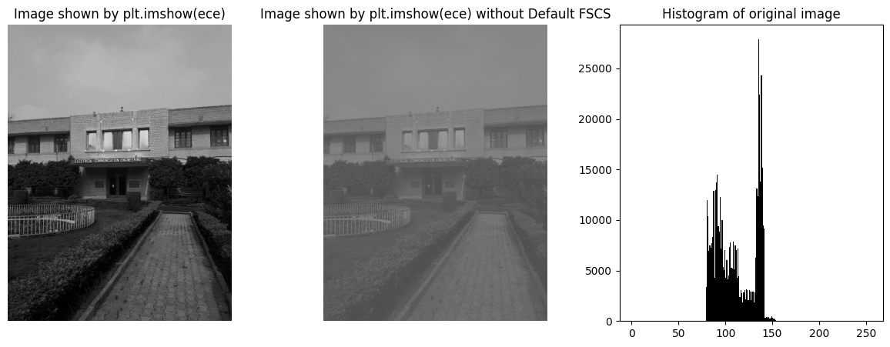

Figure 2

The vmin = 0 and vmax = 255 arguments in the plt.imshow() function implies that the max and min pixel value of the image can be 255 and 0 respectively. So, no FSCS occurs. Also, this problem only arises if the min pixel value of the image is greater than 0 and max pixel value is less than 255.

**Q2. Contrast Stretching:**

**Observations/Results:**

The value of γ is found by optimizing the mean squared error between the Histogram Equalized image and the Gamma Transformed Image.

The optimal value of γ is found to be **3**.

Figure 3

In the above figure (Figure 3), the processed image and its histogram and CDF is given for both the methods (Histogram Eq and Gamma Transform).

**Comments/Inferences**:

Histogram Equalization (HE) is a non-linear operation that attempts to make the histogram as flat as possible or the CDF as close to the ramp as possible. It is non-linear because all the intensities are not mapped in the same manner. The mapping majorly depends on the frequency of the intensity in the Image. In a discrete Image, it is not possible to create an exactly flat histogram from a non-flat histogram or a perfect ramp CDF. But, making the CDF as close to ramp as possible can create an image with **improved** contrast.

The Gamma Transform also is a non-linear operation like HE. Since the method of non-linear mapping of intensities is different, the final output image is also different to that of the HE Image. Though, the lower valued intensities are more closely packed than those of higher valued ones. This occurred due to the exponent nature of the transformation **J (i, j) = I (i, j) γ.**

**Q3. Image rotation:**

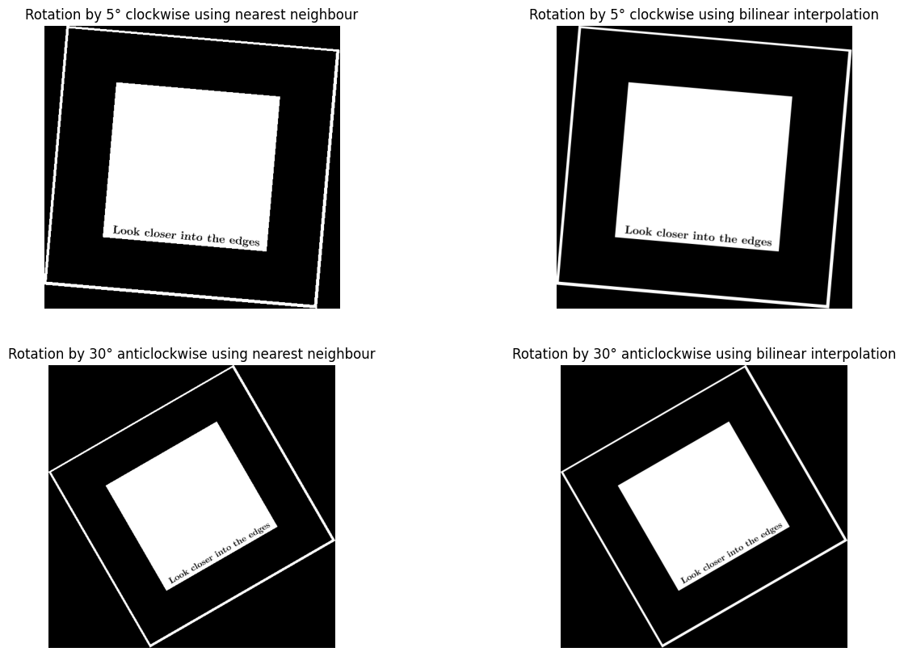**Observations/Results:**

Figure 4

Figure 5

The above figure (Figure 5) shows the original image (Figure 4) rotated 5° in clockwise direction and 30° in anti-clockwise direction using two methods of interpolation (Nearest Neighbor, Bilinear Interpolation).

It can be observed that the rotated images with Nearest Neighbor Interpolation method have zagged, and rough edges compared to the ones with bilinear interpolation which have relatively smoother edges.

**Comments/Inferences:**

The difference in the edges of the images from different interpolation methods is due to the following reason:

* The nearest neighbor method rounds off the index values which are not integers to their nearest integer index. This causes the pixel values to take step like characteristic causing the edges to be zagged. Whereas bilinear interpolation takes weighted average of the neighboring four pixels which results in a much smoother edge.

**Additional Observation:** The zagged nature of the edges is more profound in the image where rotation is less (5°) compared to the one with more rotation (30°) where the zagged nature is more subtle. The reason for this is that more rotation (till a certain degree) causes the image size to be increased more which increases the number of pixels and inherently the resolution of the image. Increasing resolution has an anti-aliasing effect which makes the zagged nature more subtle.

**Q.4 Spatial Filtering:**

**Observations/Results:**

Figure 6

The above figure shows:

1. The Original Image
2. The Original Image sharpened by using High-Boost Filtering using 5*5 Square Averaging Filter for masking.
3. The Original Image blurred by using a 3*3 Square Averaging Filter.
4. The Blurred Image sharpened by using High-Boost Filtering using 5*5 Square Averaging Filter for masking.

It can be observed that sharpening the original image results in a noisier image compared to sharpening the blurred image.

It can also be observed that, sharpening the blurred image results in a sharper image than the original image.

**Comments/Inferences:**

Sharpening the original image amplifies the noise also, which results in a noisier image after sharpening when compared to the image where sharpening was done after blurring the image by a 3*3 square averaging filter.

Blurring reduces the noise and so, after sharpening the blurred image, the noise of the sharpened image comes out to be relatively less.